**Homework 06: Quantum Dynamics I**

**PHYS550 – Quantum Mechanics I**

**Gabriel M Steward**

**September Oct 21-24, 2021**

***Additional Texts Referenced: Introduction to Quantum Mechanics, Griffiths and Schroeter***

**Problem 2.2**

*Look again at the Hamiltonian of Chapter 1* ***Problem 1.13****. Suppose the typist made an error and wrote H as*



*What principle is now violated? Illustrate your point explicitly by attempting to solve the most general time-dependent problem using an illegal Hamiltonian of this kind. (You may assume H11=H22=0 for simplicity.)*

First of all, it’s blatantly obvious that H is **not Hermitian** which is a pretty clear violation. So show that, we just take the matrix form of the given Hermitian and show that it is definitely not equal to the transpose conjugate.



Now, with H11=H22=0, we shall now attempt to solve the time-dependent problem and show, quite simply, that the answers it produces are nonsense. First of all, we need the time evolution operator.



Let’s assume t0=0. We can already see that this is going to be nonsense, as the time evolution operator is supposed to be unitary. Unitary operators multiply with their transpose conjugates to be the identity matrix. As we can see, this is not the case.

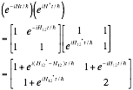

No matter what H12 is, this is clearly not unitary. (The “2” makes this clear). But let’s go ahead and plug a general vector into it anyway. If we try to take we end up with which, if U were *unitary,* would revert to as we would expect. However, as we just showed U is not unitary and so there are a ton of t-dependent terms left over no matter what the state actually is. Evaluating this product with arbitrary values “x” and “y” for the vectors gives us…



Which has a clear time dependence unless x=0. But here’s the problem, the Hamiltonian is clearly for a two-state system. For a normalized eigenstate x can’t be zero for *both* states. Thus, we have unavoidable time dependence.

All this to say trying to use an illegal Hamiltonian produces all kinds of wrongness.

**Problem 2.3**

*An electron is subject to a uniform, time-independent magnetic field of strength B in the positive z-direction. At t=0 the electron is known to be in an eigenstate of* ***S•n^*** *with eigenvalue ћ/2 where* ***n^*** *is a unit vector lying in the xz-plane that makes an angle β with the z-axis.*

We know from previous homework that the given eigenstate is represented by the vector:



There are a few more things we need to get out of the way. First of all, the Hamiltonian for an electron subject to a uniform magnetic field in Z is



Which is in terms of z so we need to be careful later on when working in other coordinates. The properties of Sz are important to note.



Also the definition of ω for completeness sake.



Now we are equipped to solve the problem.

*a) Obtain the probability for finding the electron in the Sx=ћ/2 state as a function of time.*

First of all, get the time evolution of our state via U.



We split up the vector so Sz can act on it quickly, with no need to go through all the matrix algebra steps.

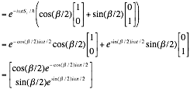

This is our time evolving eigenstate. We now seek to find the probability of Sx up, which is represented by the known vector 1/√2(1, 1). We multiply it through and square it:

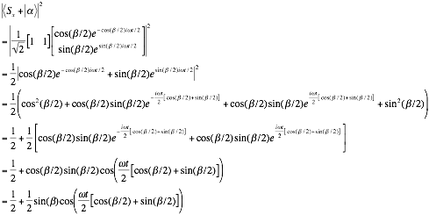

Which is the probability of Sx+ at time t. This, at t=0, reduces to (1+sinβ)/2, which is what we achieved for the non-time-dependent case on **Problem 1.14**. Also it can’t be greater than 1, which is always a good sign.

|  |
| --- |
|  |

*b) Find the expectation value of Sx as a function of time.*

The expectation value can be found via 1.98:



Which, for our case, is

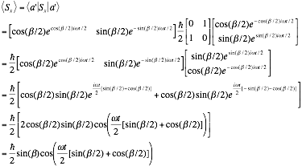

Which also matches **Problem 1.14** for t=0, as it should.

|  |
| --- |
|  |

*c) For your own peace of mind show that your answers make good sense in the extreme cases β->0 and β->π/2.*

For the zero cases we have:

|  |
| --- |
|  |

Which is very sensible. If we have equal chances of spin up or down of course the expected value is zero. In this case the electron is aligned with the magnetic field and it will never change with time, and as we know from before something pointig spin-up in the z direction has equal chances for either spin in the x direction.

And for the π/2 cases we have:

|  |
| --- |
|  |

Now this changes with time; however, at t=0 we see a probability of 1 and a guaranteed spin-up expectation, which makes sense as in this case the electron would be pointing in the x direction. However, since it is pointing in the x direction and is *not* aligned with the magnetic field, it naturally starts to precess around the magnetic field, giving the time-dependent behavior seen here.

**Problem 2.10**

*Let*  *and be eigenstates of a Hermitian operator A with eigenvalues a’ and a’’, respectively (a’≠a’’). The Hamiltonian operator is given by:*



*Where δ is just a real number.*

*a) Clearly*  *and* *are not eigenstates of the Hamiltonian. Write down the eigenstates of the Hamiltonian. What are their energy eigenvalues?*



Writing the Hamiltonian as a matrix, we get:



And since we are paranoid from the first problem we confirm that, yesthis is hermitian and therefore a legal Hamiltonian. We now need to find the eigenstates and eigenvalues that satisfy the usual . There should be two solutions to this as we have a 2x2 matrix. Since the Hamiltonian is so simple we can determine this just by looking at it—no need to go through all the steps to forcefully derive the states and vectors. The normalized vectors (1,1) and (1,-1) do the trick:



Note that this is basically just the same as the Sx operator, except with a different eigenvalue. This is effectively spin up and spin down by a different name.

*b) Suppose the system is known to be in state*  *at t=0. Write down the state vector in the Schrödinger picture for t>0.*



Not entirely sure what the “Schrödinger picture” means but we can apply the time evolution operator to get the state vector as it depends on t.

We can represent with (1,0) as that’s what it is on the Hamiltonian’s coordinates. We operate on it with the time evolution operator—but as in **Problem 2.3** we will have to split it up to use our known eigenvalues. Like so:



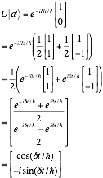

Just because there’s an imaginary number in this state does *not* mean it’s a physically unrealizable state. The realness of it should become evident in the next part.

|  |
| --- |
|  |

*c) What is the probability for finding the system in for t>0 if the system is known to be in state*  *at t=0?*



We seek the probability of a’’ given a’. The method is the same as **Problem 2.3**

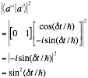

|  |
| --- |
|  |

Which is reasonable since at t=0 there is no chance, and the chance always stays at 1 or less but never below zero. Furthermore it’s never imaginary.

*d) Can you think of a physical situation corresponding to this problem?*

As already mentioned, **This is basically exactly the same as Sx** just with a different eigenvalue than normal. As for part c), this would be **the probability of spin down in Sz when the initial state is spin up calculated within the Sx Hamiltonian**. If we put an electron in an electric field the situation would be almost identical to **Problem 2.3**, just with a few axes swapped around. (Specifically, B is pointing in the positive x direction.)